Project Progress Report
Topic:
A comparative study of modern invariants of the Material Point Method: MLS-MPM, A-ULMPM, and CK-MPM
Group member:
- Lorene Wang lelinw@andrew.cmu.edu
- Korawich Kavee kkavee@andrew.cmu.edu

1. Problem statement and goals
As mentioned in the previous proposal, our goal remains to evaluate and compare the performance, stability, and physical accuracy of 3 MPM methods, namely the CK-MPM (Compact-Kernel), A-ULMPM (Arbitrary Updated Lagrangian), and the MLS-MPM (Moving Least Squares).

2. Literature review and background
Please see Table 2 for a summary table at the end of Section 2

2.1. CK-MPM (Compact-Kernel)
CK-MPM is designed to use a smaller compact interpolation kernel in order to improve computational efficiency. A smaller support radius of 2 reduces the size of the computational stencil and is more suitable for high-performance implementations, especially on modern GPU architectures. However, using such a linear kernel alone would cause a non-differentiability problem. To address this, CK-MPM introduces an additional correction term S(x) into the transfer formulation. However, the inclusion of S(x) alters the discrete representation and breaks the standard first-order consistency that holds under the original single-grid linear formulation. To restore the desired approximation properties, CK-MPM adopts a dual-grid construction, introducing two paired grids G− and G+, which can be interpreted as slightly shifted representations that together compensate for the inconsistency introduced by the correction term.
For implementation, on the algorithmic side, it adopts the G2P2G pipeline, which organizes the particle-grid transfers more compactly than the standard P2G–grid update–G2P sequence, thereby reducing intermediate storage, global memory traffic, and kernel-launch overhead. On the data structure side, the framework uses an Array-of-Structures-of-Arrays (AoSoA) design together with block-based grid storage: the grid is partitioned into contiguous 4×4×4 blocks, and within each block, attributes are stored in a Structure-of-Arrays (SoA) layout to enable coalesced GPU reads and writes while preserving block-level locality.

The main implementation challenge for CK-MPM is that it introduces a dual-grid system rather than a single grid, so particle transfers must access corresponding data from both G−​ and G+​. If these two grids were stored independently, memory access would become much more scattered and would degrade GPU efficiency. To address this, the authors extend the original block-based storage scheme by grouping corresponding blocks from the two grids together in memory. This allows the data needed for dual-grid transfers in the same spatial region to remain local, supports parallel access to both grids, preserves the original framework’s block-level locality as much as possible, and prevents the dual-grid design from significantly harming coalesced memory access on the GPU. Relatively speaking, this parallel challenge for A-ULMPM looks relatively minor by comparison to the other 2.2 and 2.3.

2.2. A-ULMPM (Arbitrary Updated Lagrangian)
A-ULMPM addresses two fundamental numerical issues that affect standard Eulerian MPM (EMPM): the cell-crossing instability and numerical fracture. In EMPM, stress and strain are measured with respect to the current configuration at each time step, which means that when particles undergo large deformations and move far from their original cells, the interpolation kernels and their derivatives no longer accurately reflect the material topology, leading to non-physical fracturing. The existing alternative, total Lagrangian MPM (TLMPM), completely fixes these issues by always measuring with respect to the initial configuration, but in doing so it loses the ability to handle extremely large deformations such as those arising in fluid simulations, since the fixed initial topology cannot represent the drastic changes.

A-ULMPM resolves this tension by introducing a general framework that spans from total Lagrangian to Eulerian formulations. Rather than always using the initial or the current configuration as the reference, it allows the reference configuration to be set to an arbitrary intermediate time t_s. The governing equations are derived from a nodal discretized Lagrangian rather than the weak form used in MLS-MPM, which naturally leads to a modified MLS-MPM formulation that recovers standard MLS-EMPM as a special case when s = n. The key adaptive component is a physics-based criterion that monitors the determinant of the incremental deformation gradient: when the fraction of particles whose local volume change exceeds a threshold η reaches a sufficient proportion of the total particle count, the reference configuration is updated and the interpolation kernels, their derivatives, and the K matrices are recomputed. Between updates, all these quantities remain fixed, which means the method inherits the zero cell-crossing error and zero numerical fracture properties of TLMPM while only incurring the kernel update cost when the deformation actually demands it. In fluid-like simulations, this selective updating results in 4.27× to 31.52× less overhead for configuration updates compared to standard EMPM.
The main implementation challenge is the dependency on the external Nova framework for its sparse grid infrastructure. The original codebase is not self-contained, which makes it difficult to port into other simulation pipelines without substantially re-engineering the underlying data structures. In our project, rather than attempting to fully reconstruct the original environment, we plan to reproduce comparable A-ULMPM test cases within the CK-MPM pipeline and computing environment.

2.3. MLS-MPM (Moving Least Squares)
MLS-MPM reformulates the standard MPM discretization using Moving Least Squares (MLS) shape functions in place of the B-spline basis functions traditionally used in the stress divergence term. The central motivation is that traditional MPM computes internal forces by explicitly differentiating the B-spline interpolation function, yielding a force expression that requires evaluating ∇N_i(x_p) at every particle-grid interaction. MLS-MPM shows that if MLS shape functions derived from a linear polynomial basis are used instead (with B-splines retained as the weighting function) the force computation can be reformulated so that this gradient evaluation is eliminated entirely. The resulting force on each grid node depends only on the B-spline weight N_i(x_p) and the displacement vector (x_i − x_p), both of which are already available from the APIC particle-to-grid transfer.

On the implementation side, this simplification has a direct performance consequence. During P2G, the affine momentum contribution and the particle force contribution can be fused into a single matrix-vector product N_i(x_p) Q_p (x_i − x_p), where Q_p combines the stress and the APIC affine matrix. During G2P, the velocity gradient and deformation gradient update are obtained directly from C_p without any kernel gradient evaluation. The paper reports 3.71× and 14.01× higher performance for P2G and G2P, respectively, compared to the baseline.

Beyond basic simulation, MLS-MPM also introduces the Compatible Particle-In-Cell (CPIC) algorithm, which enables material cutting, dynamic open boundaries, and two-way rigid body coupling by maintaining a Colored Distance Field (CDF) that encodes proximity and side relationships between particles and rigid surfaces. Particles and grid nodes are classified as compatible or incompatible based on whether they lie on the same side of any nearby rigid boundary, and particle-to-grid transfers are restricted to compatible pairs only.

2.4. General guideline for the comparison approach
The comparison framework was inspired by the analysis presented in Revisiting integration in the material point method: a scheme for easier separation and less dissipation (https://dl.acm.org/doi/pdf/10.1145/3450626.3459678), which systematically studies and proposes new particle–grid transfer schemes in MPM and analyzes their impact on simulation behavior. In the literature review part, we mainly focus on its comparison structure and methodology.
The paper first identifies two key goals for comparison: (1) numerical dissipation, which is primarily caused by velocity averaging during transfers, and (2) particle separation, where existing integrators assume continuity over the entire domain and advect particles by interpolating positions from deformed grid nodes, leading to positional trapping and making separation difficult.
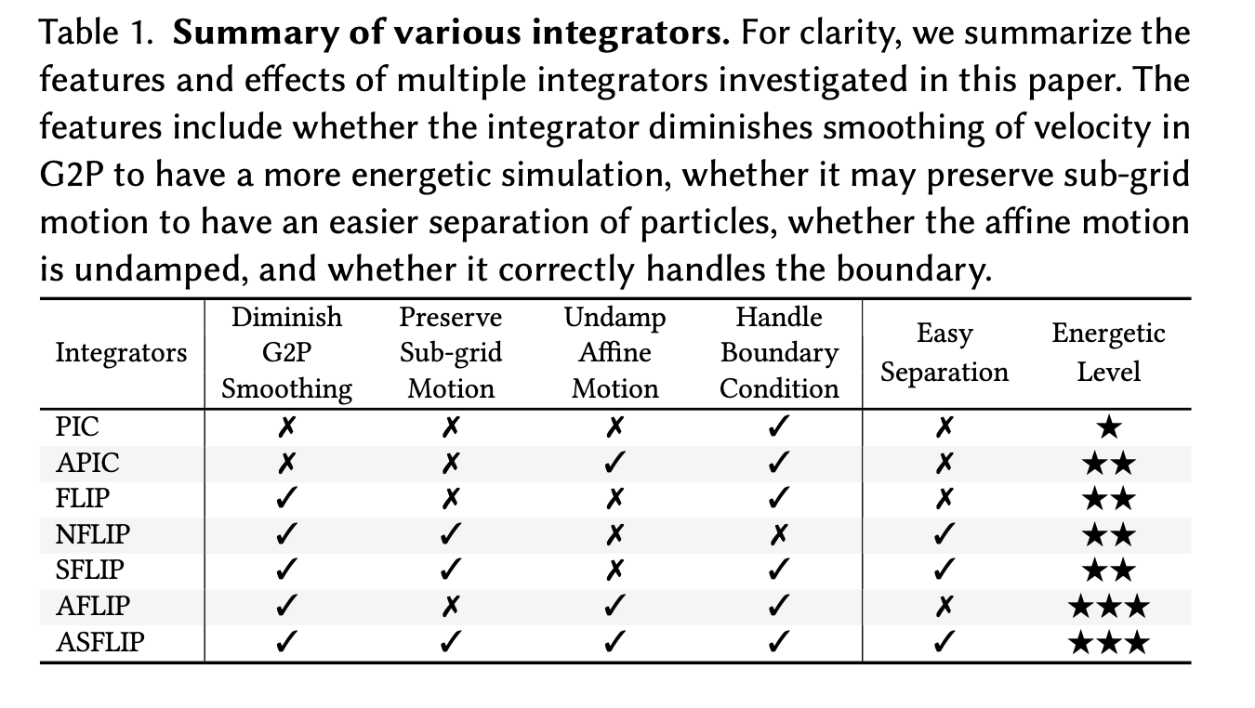
It then provides a summary of different integrators, focusing on their behavior in terms of diminishing G2P smoothing, preserving sub-grid motion (through P2G), reducing damping in affine motion, and handling boundary conditions. (See table 1)
Based on these aspects, the paper organizes a series of test cases to evaluate different methods. In 2D, these include: two particles moving away from each other within a distance of 0.2 Δx, testing how velocity averaging causes them to slow down or stop; a sand column collapse to examine whether positional trapping persists; sand pouring into an hourglass to evaluate boundary conditions and energy behavior (e.g., whether debris spreads in open regions); tearing wet clay and separating sheets to test fracture and separation; fiber piling to examine accumulation behavior; and drops a box-shaped liquid onto a rotating elastic object to demonstrate reduced damping and improved visual detail.
The paper further extends these evaluations to 3D scenarios. In the hair simulation, sub-grid motion is largely dissipated in FLIP and APIC, resulting in stiff and entangled behavior, while improved methods such as SFLIP or ASFLIP produce more fluid motion. In the sand break example, sand particles fall onto a fractured elastic plate, where excessive dissipation in FLIP/APIC leads to sticking and high apparent viscosity, whereas improved methods allow particles to slide more naturally. Finally, the pressed bush example evaluates strand–boundary interaction, strand–strand interaction, and compression behavior, highlighting differences in how integrators handle complex contact and deformation. These design choices and evaluation strategies provide a structured basis for comparison, and inspired us to define a set of common metrics for our own implementation and testing, which will be elaborated in part 3.
Table 2. Summary comparison of the three MPM methods reviewed.
 | MLS-MPM | A-ULMPM | CK-MPM
Year | 2018 | 2021 | 2025
Core problem addressed | Force computation requires evaluating ∇N_i(x), which is expensive and complicates implementation | Cell-crossing instability and numerical fracture under large deformation | Cell-crossing instability and numerical diffusion caused by large kernel support
Key idea | Replace B-spline shape functions in stress divergence with MLS shape functions, eliminating kernel gradient evaluation | Adaptively update the reference configuration only when deformation exceeds a physics-based threshold | Introduce a C²-continuous compact kernel with radius 2, paired with a staggered dual-grid to restore 1st-order accuracy
Transfer scheme | APIC / PolyPIC (P2G → Grid update → G2P) | APIC with first-order Taylor expansion (P2G → Grid update → G2P → configuration check) | G2P2G with dual-grid (transfers to/from both G⁻ and G⁺)
Reference configuration | Eulerian (updated every step) | Arbitrary: between total Lagrangian and Eulerian, updated adaptively | Eulerian (updated every step)
Momentum conservation | Linear YES, Angular YES (via APIC) | Linear YES, Angular YES (via APIC integration) | Linear YES, Angular YES (proven for PIC and APIC)
Performance | ~2× speedup over traditional MPM (explicit) | 4.27×–31.52× less config update overhead vs. EMPM | ~1.5× speedup over quadratic B-spline (Taichi/PIC); ~10% in CUDA/MLS
Handles large deformation | Limited (numerical fracture in solids) | YES (adaptive config update prevents fracture) | Limited (more prone to fracture with compact kernel)
Notable extra feature | CPIC: material cutting, thin boundaries, rigid body coupling | Spans TLMPM to EMPM; unified solid and fluid simulation | Reduced numerical diffusion; more precise contact resolution
Key limitation | Numerical fracture under large solid deformation | Nova framework dependency; configuration update frequency requires hand-tuning | Doubles grid memory; compact kernel increases fracture tendency
Demonstrated examples | Cutting, sand, water, snow, robot terradynamics | Twisting bar, yo-yo, fluid bunny, fluid-structure interaction | Sand castle, fire hydrant, bullet impact, dam break

3. Implementation and testing progress
Our script implementation is documented in the Git repository we prepared here (Link: https://github.com/Lor10111/15763-mpm ). In general, we first tested each paper’s repository for a basic replication check, in case there is a mismatch of technical script version or any hardware compatibility issue. After that, we develop a testing plan by discussing metrics to fairly measure each MPM approach.

For the replication check:
- For the MLS-MPM, we have found a small problem at first, that the simulation code has a compatibility issue with the Warp version. This is now resolved as documented in 15763-mpm/MLS_MPM_clone at main · Lor10111/15763-mpm
- For CK-MPM, we successfully set up the environment and ran test cases on a compute node. While we are able to generate simulation outputs, we have not yet fully established a workflow for visualizing the results in Houdini, and currently, we only obtain point cloud renderings. We plan to resolve this visualization issue within this week.
- For A-ULMPM, we organized the raw codebase and prepared a README. However, the original implementation depends on the external Nova framework, which is not included and currently unavailable to us. As a result, instead of attempting to fully reconstruct the original environment, we plan to begin by adapting and reproducing individual test cases within our existing framework, more specifically, to use the CK-MPM pipeline and computing environment to reproduce comparable A-ULMPM test cases

The metrics we summarized are:
- Physics Accuracy
  - Conservation: Linear momentum error/Angular momentum error/ Energy (kinetic/elastic / total)
  - Numerical dissipation: Energy decay over time/velocity magnitude decay,/ Spread distance
  - Sub-grid motion preservation(thin structures, may be discarded)
- Stability / Robustness
- stiff material/large deformation/ high velocity: timestep sensitivity/divergence/explode
- Fracture/separation behavior
- Efficiency / System performance
- Runtime
- Kernel-level breakdown
- Memory footprint
- Visual quality

The designed test based on these metrics would be shown in part 5.

4. Progress relative to your original plan
The replication of previous studies, as well as the analysis and design of test cases, took longer than we expected. As a result, we have not yet reached the stage of fully implementing the intended common experiment setup. However, we have made steady progress in reproducing existing methods and have developed a more concrete and unified experiment design with clearly defined objectives and evaluation criteria. The last feedback regarding per-component timing breakdowns is planned to be included. The implementation details are documented in our repository.

5. Preliminary results
While we have no actual results for the intended comparison, we intend to set up the problem similarly to the 3 studies we reviewed. Inspired by those, we have designed the following setups:
- Unit test for Physical accuracy:
simple, controlled conditions without external forces or boundary interactions
- Translational motion test (linear momentum conservation):
We initialize a single particle block (e.g., a square or circular cluster) with a uniform velocity field and no external forces. In this setup, the entire block is expected to undergo rigid translation with constant velocity. Since no external forces are applied, the total linear momentum of the system should remain constant over time. We measure the deviation of total linear momentum and track the motion of the center of mass to verify that it follows a linear trajectory.
- Dual-rotation test (angular momentum conservation):
We initialize two identical particle blocks placed sufficiently far apart, each undergoing rigid rotation with opposite angular velocities. No external forces or interactions are applied between the blocks. This configuration allows us to examine angular momentum conservation in a symmetric setting. In particular, we evaluate whether each block preserves its rotational motion and whether the total angular momentum of the system remains constant.
- Efficiency
- Common example+Candy Bowl:
For fair cross-method efficiency comparison, we will use a common benchmark that is implementable across all three methods under similar hardware and runtime conditions, which is to be chosen from the experiments in part 3, and we will record runtime, kernel-level breakdown, and memory footprint.
In addition, we will include a large-scale case inspired by the paper A Massively Parallel and Scalable Multi-GPU Material Point Method, the candy-bowl pouring example, and try to reproduce it with all three methods. While this setup may not be directly comparable across different implementations due to differences in hardware support and optimization levels (e.g., GPU-specific acceleration), it serves as a stress test to examine behavior under highly complex and large-scale scenarios.
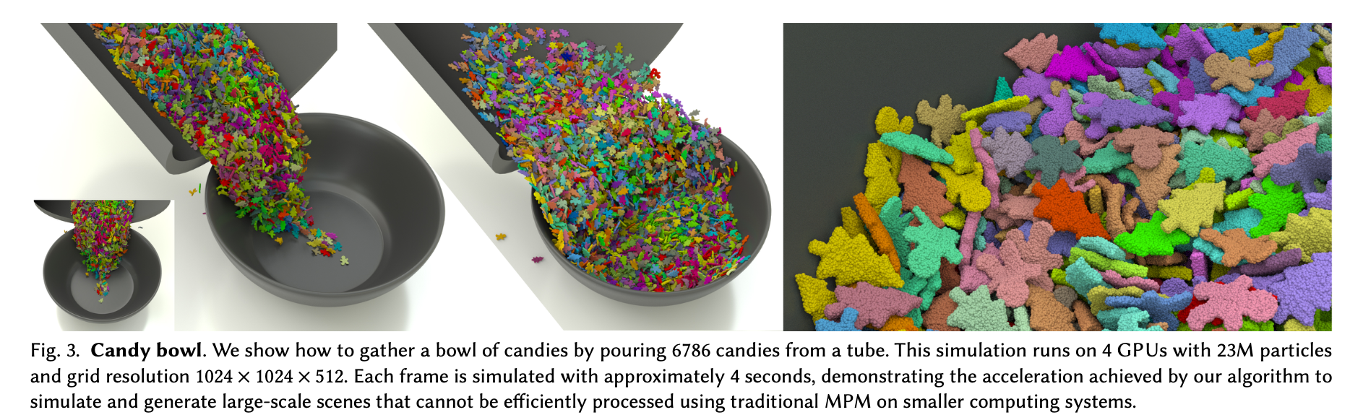

- Visual quality( including stability and robustness)(2D experiments)
- Stretching bar:
We consider a bar-shaped material initialized as a rectangular block with a high aspect ratio (length ≫ width). The bar is placed in a domain without gravity. To induce large deformation, we apply tensile loading by prescribing opposite velocities at the two ends of the bar. To further examine robustness under different physical conditions, we also change constitutive parameters to control material stiffness. This allows us to evaluate how each method behaves under both softer and stiffer material conditions, and whether they break as they should.

- Waterfall-to-bottleneck test：
For visual quality and contact behavior, we consider a waterfall-to-bottleneck test in which a continuous liquid stream falls onto a structured container and then passes through a narrow bottle-like opening. In this setup, we focus on observable flow characteristics such as flow velocity, volume distribution, and the height and extent of splashing after impact. These quantities help us assess how different methods capture contact interaction and the preservation of motion.

- Material block dropping:
Helps us visualize separation, splashing, and shattering by having a material block dropped onto a set of filters. We are considering numbering the obstacles from 1 (larger empty space) to 3 (smaller gaps between them), as shown in the figure below.

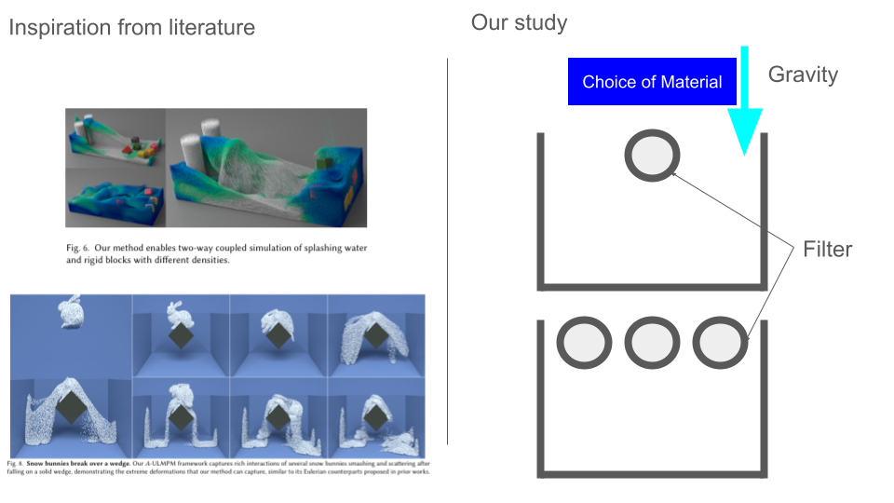

We plan to test different material types, including sand, water, and snow, with different material parameters. The main comparisons in this setup will focus on visual quality and stability-related behavior, such as fracture patterns, response under stiff materials or high velocities, and how these behaviors vary across material models and obstacle
configurations.

6. Challenges and next steps
Several challenges have emerged during the current stage of the project.
First, integrating A-ULMPM into an existing experimental framework is non-trivial. The original implementation depends on the external Nova library, which is not available in our environment. As a result, it is challenging to directly reproduce the original pipeline. We also plan to reach out to Prof. Mridul Aanjaneya's lab at Rutgers University (the Laboratory for Interactive Virtual Environments), as this is maintained by them (https://orionquest.github.io/research.html )
Second, ensuring a consistent experimental environment across different methods is difficult. The implementations differ in programming models, dependencies, and hardware support (e.g., GPU vs. non-GPU), making it challenging to establish a fair comparison, especially for efficiency evaluation.
Third, environment setup and debugging took significantly more time than expected(though it was a lot of fun!). Compatibility issues, dependency management, and remote compute nodes introduced additional information and challenges.
Finally, the design of 3D experiments remains incomplete. In addition to simulation complexity, visualization and rendering of 3D results present additional challenges, particularly in producing consistent and comparable outputs across methods.
Given the current progress and workload estimation, we plan to restructure our timeline into a weekly schedule over the remaining four weeks.
- Week 1: Implement and validate unit tests (linear and angular momentum conservation) and the stretching bar test for robustness under large deformation.
- Week 2: Implement material deformation scenarios (e.g., block dropping and fragmentation-related tests) and refine comparison metrics related to separation, splashing, and shattering.
- Week 3: Conduct efficiency evaluation and large-stress experiments, including runtime profiling and stability analysis under extreme conditions.
- Week 4: Implement and analyze visual quality and contact-based tests, such as the waterfall-to-bottleneck scenario and the stretching bar under varying conditions. If time permits, begin exploring 3D extensions and rendering workflows.
If there is any advice and feedback, please do let us know.

